CLASS RING ORDER DEADLINE


Class Ring Order Deadline is:
TUESDAY, OCTOBER 20TH

You can design your ring and submit your order at www.jostens.com
or by scanning the QR code below:
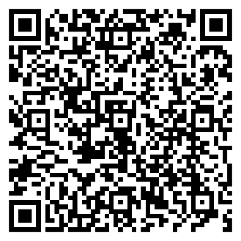
To receive the current exclusive group pricing and promotions available for your school order period, you must submit your online order by OCTOBER 20th.



